Setting a scene for a people’s budget
The national economic recession that started during the first quarter of 2009 formally ended during the third quarter of 2009. It was in hindsight a very quick but dramatic period. The end of the recession culminated in the beginning of the recovery. Initially the quick and dramatic scenario was also envisaged for the recovery because of the massive international fiscal and monetary responses to the recession. The responses on most levels were unprecedented creating the impression of a quick and dramatic recovery. This has proven not to be the case.
Growth
In 2009, the national economy recorded a negative growth rate of 1.7 %. This is a swing of 5.3% points from 2008. Estimates from Statistics South Africa (Stat SA) indicate that the national economy recorded a growth rate of about 2.8 % during 2010 signalling a 4.5% point swing during 2010 which if assumed that 2008 was normal suggests that the recovery phase is still in process. Thus 2010 was a period of economic recovery which started during the latter part of 2009, but the recovery has not yet ended. In fact it seems that the recovery itself has run into serious difficulties, this has been evident by a decrease in the quarterly seasonal adjusted growth rates recorded during the first three quarters of 2010 (4.6%, 2.8% and 2.6% respectively).
Recovery
The slowdown in the recovery suggests that 2011 will also be a very frustrating and difficult year not that dissimilar to 2010. The issue or probability of a double dip recession is still lingering although more and more unlikely because of the time that have passed since the start of the recovery. However what also seems very evident is that the quick and dramatic scenario has not and will not occur because of the unwinding of the international expansionary policies. The ever increasing consensus view seems to suggest a fairly moderate but lengthy recovery lasting well into 2011 and even into 2012. 2011 will most likely be characterised by moderate economic growth and the recovery of most macroeconomic indicators, but the stagnation of employment, income and most social indicators. This will most likely also be the scenario for the province during 2011. Economic growth for the province is estimated to be in the 3% - 3.5% range during 2011.

Overview of KZN’s Social and Economic Indicators
- GDP-R (Q4 2010) KZN’s real GDP was R 300.1 billion in the fourth quarter of 2010, contributing only about 16.4 % to the national GDP.
- GDP growth rate was 3.4% with
Finance contributing 5.45% to GDP-R, while the government services contributed only 1.9 %.
- Unemployment (Q3 2010):
The provincial unemployment rate stood at 19.8 % (KZN) compared to the national 24.0%
- Poverty (2009)
The poverty rate in the province is 50%. This is an indication that half of the population is in poverty.
- The Development indicators (2009)
The literacy rate was 68.7 %, while the Human Development Index (HDI) was 52%
- Demographics (2010)
Total Population 10.6 million
Population annual growth 1.88 %

Structure of the Kwazulu-Natal Economy
The contribution of both the primary and secondary sectors to the provincial GDP decreased, while the contribution of the tertiary sector to the provincial GDP increased. The contribution of the primary and secondary sectors to the provincial GDP decreased from 7.8 % and 30.9 % to 5.6 % and 27.2 %, respectively, while the contribution of the tertiary sector to the provincial GDP increased from 61.3% to 67.2% since 1996. It also seems that the structural changes intensified during the recession suggesting that the primary and especially the secondary sectors were relatively worse affected by the recession than the tertiary sector. It must also be emphasized that a decrease in contribution by no means implies a decrease in absolute terms, but only a decrease in relative terms.

KwaZulu-Natal grant beneficiaries per grant type as at 31 August 2010
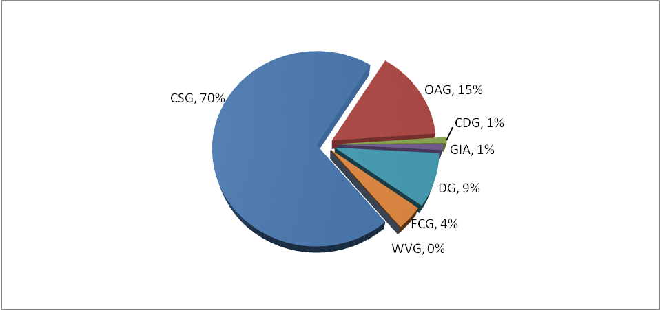
According to the type of grant (graph 2.11), the Child Support grant is the highest beneficiary at 70%, followed by Old Age Grant (OAG) at 15%, Disability Grant (DG) at 9%, Foster Child Grant (FCG) at 4%, Grant in Aid (GIA) at 1% and Child Dependency Grant (CDG) at 1%. The least beneficiary who does not make any significance in the province is War Veteran’s Grant (WVG) at 0%.

POLICY PRIORITIES

New Growth Path
The government has introduced the New Growth Path as a strategy towards sustainable growth and creation of decent jobs. 2011 has been declared as the year of job creation and initiatives have been taken to ensure that the primary focus of government is the creation of decent jobs.
Flagship
It is 18 months after the launch of the flagship programme under the campaign “one home one garden.” Achievements and challenges have been noted and the rebranding of the programme is to give it a necessary impetus with a clear call for all to participate. The HODs have decided to develop turnaround strategies for each district to reinforce the programme which will integrate its rebranding. The re-launch of the branded provincial Flagship programme starting at uMgungundlovu followed by all districts in the sequence as decided upon by the leadership.

Education
Education is still a top priority within national government as it is a foundation on which the future of our country will be built. This has been confirmed by the larger portion of the national budget being allocated to education. The provincial government has also once again followed suit by giving education top priority. The increase in budget allocation in education is dedicated to the Provincial 10-point plan, which is an intervention to support poorly performing schools and is used as a reporting instrument for the matric improvement plan and the collaborative effort of officials, learners, educators, parents and communities to improve and support education as government priority number one.
Health
The KZN Department of Health’s vision is the optimal health for all persons in the province and they aim to develop and deliver a sustainable, co-ordinated, integrated and comprehensive health system at all levels of care based on the primary health care approach. Health remains one of the top key priorities in the province with the main focus being: Increasing Life Expectancy; Decreasing Maternal and Child Mortality; Combating HIV and AIDS and decreasing the burden of diseases from Tuberculosis; and strengthening the health system effectiveness.
Agrarian Reform – Rural Development
Agrarian reform is a rural development strategy to stimulate agricultural production with a view to contribute to food security. In this regard the government aims to support the provision of agricultural equipment and inputs to support emerging farmers and households nationally. Crucial to the effort of achieving food security are a number of stepwise interventions that move from protecting natural agricultural assets through LandCare projects, household and small farmer support (Mechanization, inputs and infrastructure), Land reform post-settlement support, extension improvement, and finally research support to improve commercial farming enterprises.
Creation of Decent Jobs
The national government has budgeted R39 billion to finance new job creation initiatives. President Jacob Zuma highlighted that the private sector would play a major role in a country’s efforts to create more jobs in order to beat unemployment. In many areas of the jobs drivers, departments have already initiated strategies to support employment creation, currently departments are reviewing their policies and programmes to create jobs.
KZN’s Share of National Budget- 2011
KwaZulu-Natal receives the largest share of equitable share revenue at 21.8%, followed by Gauteng and Eastern Cape at 17.5% and 18.3% respectively. The provincial equitable share will grow at a constant rate of 0.5% over the Medium Term Expenditure Framework (MTEF) period
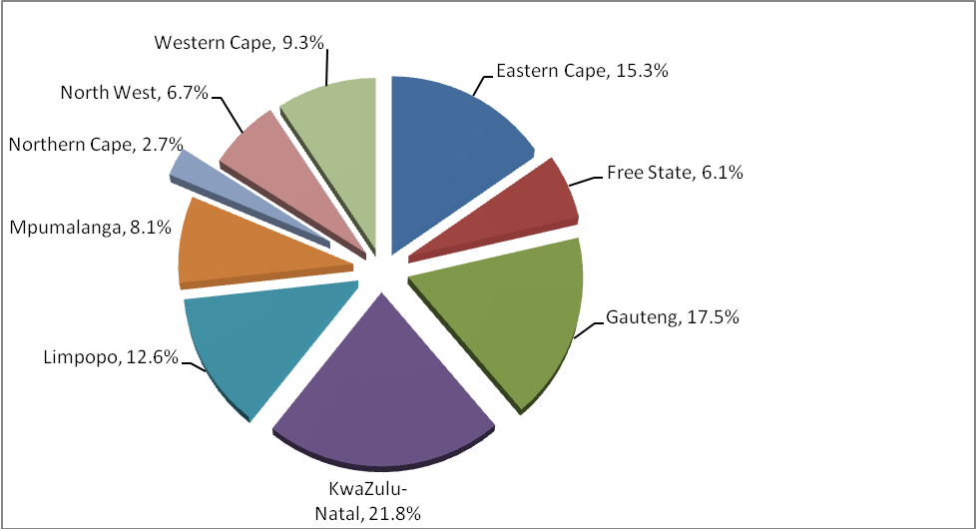
Summary of Total Receipts - 2011
KwaZulu-Natal’s budgetary receipts are made up of 80.5% equitable share received from National Treasury, 17% as conditional grant funding from national departments and 2.5% as its own revenue, collected by provincial departments.
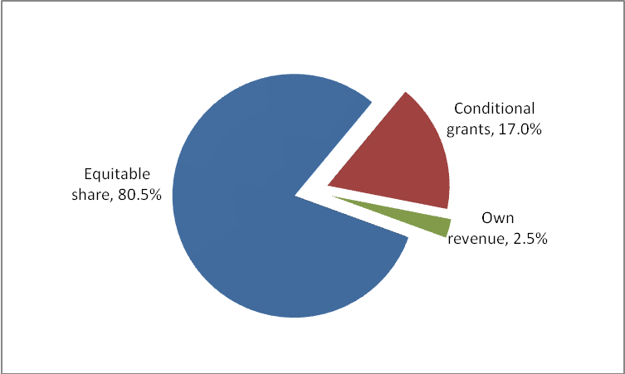

Percentage Share of the Total Budget: Allocation by Departments - 2011

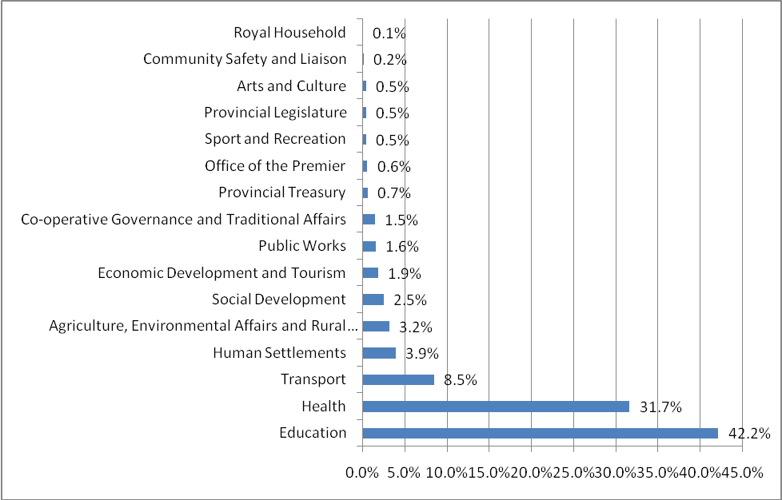

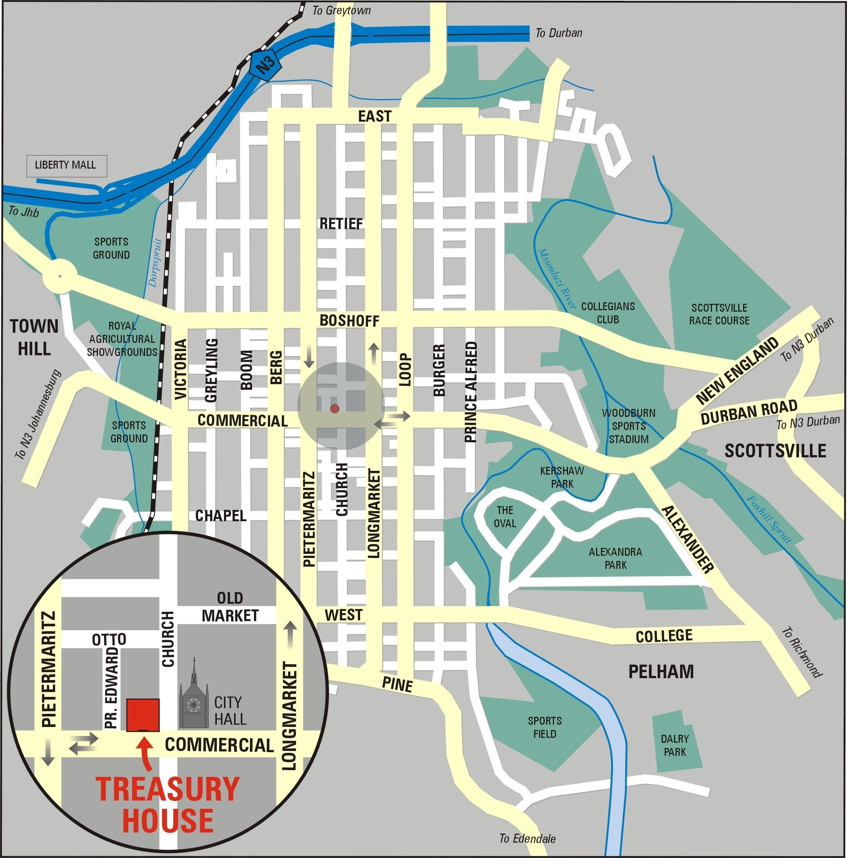

Province of KwaZulu-Natal
PROVINCIAL BUDGET 2011
“The KZN Budget: Making people’s lives better”
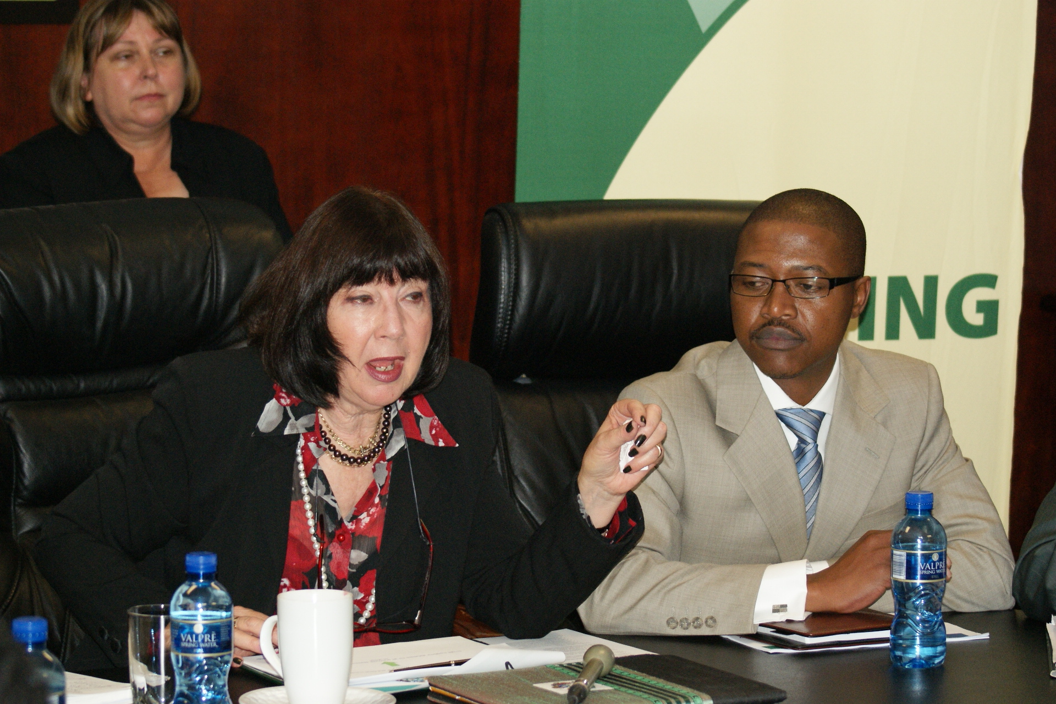
Spend your money wisely
KZN Provincial Treasury’s Vision
“Be the centre of excellence in financial and fiscal management in the country”

KwaZulu-Natal Provincial Treasury
Treasury House
145 Chief Albert Luthuli Road
P O Box 3613
Pietermaritzburg
3201
Tel: 033 897 4200
Fax: 033 342 2632
Website: www.kzntreasury.gov.za

